Abdelrahman Ahmed Elkady 202201023

**Report for calibre.**

Github repo: https://github.com/kovidgoyal/calibre

Calibre is an open-source e-book management software that allows users to organize, convert, and manage their e-book collections. Here are some details about Calibre:

1. **Inception of the Project:**
   * **Initiator:** Calibre was initiated by Kovid Goyal.
   * **Reasons behind its creation:** Calibre was created to provide a comprehensive solution for managing e-book libraries. Kovid Goyal wanted to create a tool that could handle various aspects of e-book management, including organization, conversion, and syncing with e-book readers.
2. **Original Owner:**
   * **Original Owner:** Kovid Goyal is the original owner and primary developer of Calibre.
3. **Type of Software Licensing:**
   * **Software Licensing:** Calibre is distributed under the GNU General Public License (GPL). It is free and open-source software, allowing users to view, modify, and distribute the source code.

Calibre's open-source nature encourages collaboration and community contributions, making it a widely used and respected tool in the e-book management community.

**Languages**

[Python 77.1%](https://github.com/kovidgoyal/calibre/search?l=python)

* [C18.8%](https://github.com/kovidgoyal/calibre/search?l=c)
* [C++3.1%](https://github.com/kovidgoyal/calibre/search?l=c%2B%2B)
* [HTML0.4%](https://github.com/kovidgoyal/calibre/search?l=html)
* [Shell0.2%](https://github.com/kovidgoyal/calibre/search?l=shell)
* [XSLT0.2%](https://github.com/kovidgoyal/calibre/search?l=xslt)
* Other0.2%

**Functionality**

Calibre is an open-source e-book management tool that excels in converting and organizing digital libraries. It supports diverse e-book formats, features a built-in WebKit-powered viewer, and provides a content server for remote access via CherryPy. Calibre simplifies metadata management and cover art, supports OPDS for easy sharing, and boasts a user-friendly interface. With automated metadata retrieval and continuous community support, Calibre is a versatile solution for e-book enthusiasts and professionals.

**Utilized Technologies:**

1. **Programming Language:**
   * Python
2. **Graphical User Interface (GUI):**
   * Qt (utilized for creating the graphical user interface)
3. **E-book Formats and Conversion:**
   * ePub, MOBI, PDF, etc. (utilized for supporting and handling various e-book formats)
   * Calibre Conversion Engine (specifically developed for Calibre)
4. **Database:**
   * SQLite (utilized as the default database)
5. **Web Server for Content Server:**
   * CherryPy (utilized as the web framework for the content server)
6. **E-book Metadata Sources:**
   * OPDS (utilized for accessing and sharing e-books)
7. **E-book Viewer:**
   * WebKit (utilized as the rendering engine for the built-in e-book viewer)
8. **Command Line Interface (CLI):**
   * Calibre CLI (utilized for various operations)
9. **Cryptography:**
   * Various Python cryptography libraries (utilized for securing communication and encryption)
10. **Localization:**
    * Calibre supports multiple languages, and the translation framework in Python might be utilized.

**Presence of Off-the-shelf Tools:**

Qt (as a framework for GUI) and WebKit (as a rendering engine) can be considered off-the-shelf tools, although they are also utilized in the development process. The term "off-the-shelf" typically refers to pre-existing, ready-to-use tools or components that are incorporated into a system or application. In this context, Qt and WebKit are widely-used frameworks that provide functionality beyond Calibre's specific implementation.

** I will submit a zip file with a file for every analyzed release and the static analysis tool export for it in that same file

**Snapshots of some of the data looked at in our repoprt:**

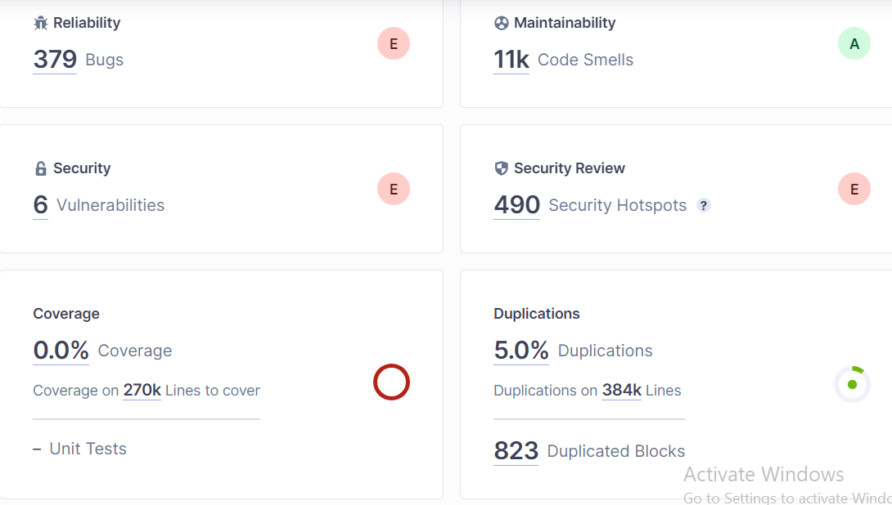

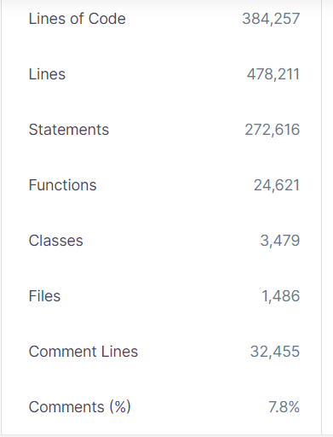

This is some the data that will be looked at plus the clean code metrics .We will look at some attached tables talking about some specific metrics and what can be concluded from it

The amounts of bugs with each release:

Also the final release has bugs which indicates that Releasing software with some bugs is common and often deemed acceptable within the software development process.

Bug counts show variability across releases. Versions 2.1 to 2.16 see a slight increase, while 3.44 decreases to 397 bugs. Version 4 shows a notable drop to 364 bugs. Releases from 4.22 to 5.82 maintain a mid-360s range. Version 6 increases to 372 bugs, continuing in 6.26 and 7.1. The bug landscape indicates ongoing efforts to address issues in each release.

Conclusion: Bug counts vary across releases, reflecting an ongoing effort to address issues and enhance software stability. While some versions show notable decreases, others exhibit minor fluctuations, underscoring the iterative nature of software development and the continual pursuit of improvement towards code of better quality

Top of Form

**Reliability with time:**

If the reliability metric of a software remains constant (denoted as "E") throughout all releases, it suggests a consistent level of reliability is maintained across different versions. This could be a positive indicator, signaling that the development team has successfully sustained a certain standard of reliability or that improvements and bug fixes have not negatively impacted the overall reliability of the software. However, it's important to note that other metrics and user feedback should also be considered to comprehensively assess the performance and quality of the software.

BUT this reflects that the quality of code is not that up to par

Top of Form

L.O.C And Effects on quality of code

The data implies a correlation between lines of code (LOC) and major/critical issues, with a tendency for issues to increase alongside LOC changes. However, it's crucial to note that code quality is not solely determined by code size. Factors beyond LOC, such as development practices and the complexity of functionality, play significant roles in influencing the overall quality of the codebase across software releases.

Top of Form

**Release version v loc:**  
Across the software releases, there appears to be a concerted effort to reduce lines of code (LOC) in pursuit of improved code simplicity and potentially lower bug counts. The trend suggests a strategic approach to enhance code quality. However, this simplicity drive may have trade-offs, as observed in the final release (7.1), where LOC increases to accommodate additional features. This compromise indicates a balance between code simplicity and functionality requirements. It's a common challenge in software development, where teams aim to minimize complexity for better maintainability and bug reduction, yet must contend with the demand for new features in the final release. This delicate balancing act highlights the nuanced decision-making involved in optimizing code quality throughout the software development life cycle, acknowledging that sometimes a slight sacrifice in code quality is made to meet the broader objectives of feature-rich releases.

The provided data shows the relationship between the number of bugs and lines of code (LOC) in the software. While the data doesn't reveal a strictly linear correlation, there are fluctuations in bug counts as LOC changes across different releases. Notably, the decrease in bugs from 399 to 364 corresponds to a decrease in LOC. This suggests a potential trend where a lower LOC is associated with a reduction in the number of bugs, emphasizing the importance of code simplicity and conciseness in mitigating software issues. However, the relationship is complex, and additional factors such as coding practices and the nature of functionality should be considered for a comprehensive assessment of code quality.

Top of Form

The data on security hotspots and lines of code (LOC) suggests an intriguing relationship in the software development process. A noticeable pattern emerges, indicating that as LOC decreases, the number of security hotspots also tends to decrease. This trend is particularly evident in the efforts of newer releases, where deliberate attempts to reduce LOC coincide with a decrease in identified security hotspots. This correlation implies that a leaner and more concise codebase may contribute to lower security risks. The proactive approach of minimizing LOC in recent releases not only aligns with the industry best practice of enhancing code quality through simplicity but also appears to have a positive impact on the software's security posture. This reinforces the notion that prioritizing code simplicity and quality can serve as an effective strategy for mitigating security vulnerabilities in the software development lifecycle.

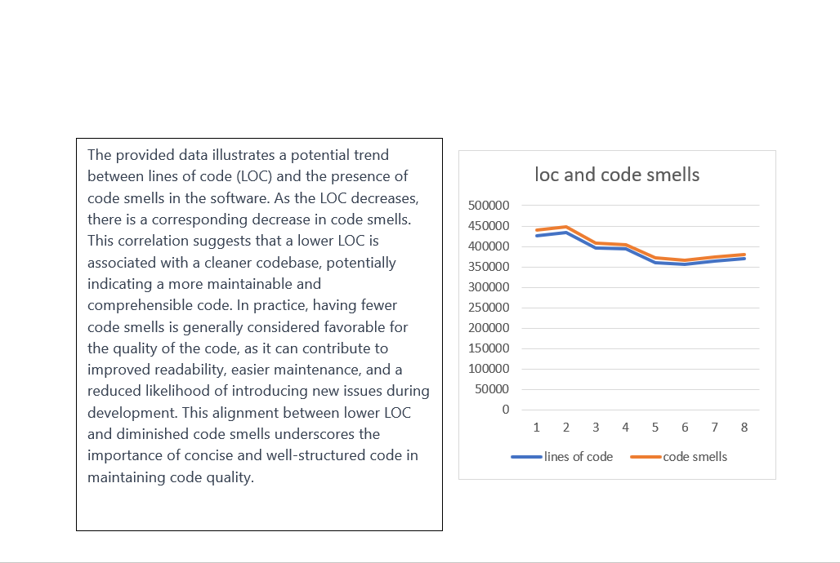

**To conclude:**

The metrics, including lines of code (LOC), bug counts, security hotspots, major issues, and code smells, collectively reveal crucial insights into software quality. A consistent trend indicates that lower LOC is associated with fewer bugs, security hotspots, major issues, and code smells, suggesting that a streamlined codebase positively influences overall code quality. Notably, recent releases exhibit a deliberate reduction in LOC, aligning with industry best practices and resulting in improved software reliability, security, and reduced code issues. However, the nuanced challenge lies in balancing code simplicity with the demands of additional features, as seen in the slight compromise observed in the final release. In summary, the metrics affirm the complex interplay between code characteristics and software quality, emphasizing the ongoing endeavor to strike an optimal balance in the software development lifecycle.